Top of Form

Bottom of Form

**The Crafty *mycelium* effect**

Mycelium represents an extensive subterranean network composed of fungal threads that serves as an essential support framework for plant life. This intricate system, referred to as mycorrhiza when it establishes a symbiotic association with plant roots, facilitates the exchange of nutrients, water, and even information among diverse plant species. Through mycelium, trees and plants engage in communication, resource sharing, and can even warn one another of impending threats.

For instance, when a tree is felled within a forest, the mycelial network promptly alerts adjacent trees to the distress signal. These interconnected trees then respond by redirecting nutrients and water to the affected tree's stump, striving to sustain its vitality. Such interdependence is critical to the overall health and survival of the forest ecosystem, with each tree playing an indispensable role in this biological community.

Envisioning a human society that mirrors the functional support system exemplified by mycelium conjures an image of profound empathy and collaboration. In such a societal structure, individuals would possess heightened awareness of each other's needs and struggles. During times of adversity, the community’s response would be rapid and unified, ensuring that no individual faces hardship in isolation. Resources would be equitably allocated, nurturing a robust sense of community and mutual reliance.

In this idealised society, the principles of empathy and assistance would be inherently ingrained, fostering a resilient and nurturing environment. Analogous to the mycelium network, which sustains and safeguards the forest, a human community built on shared support and care could ensure the flourishing of every individual. This interconnectedness would promote a culture of solidarity, where caring for one another is intrinsic to the human experience, reminiscent of the natural processes that underpin a thriving forest.

Should humanity embrace such a framework, the world would transform into a realm where compassion and support are as elemental as the mycelial threads that unify the forest ecosystem.  
  
We submit hands-on-human craft has a ‘ground-up’ homologue effect to Nature’s mycelium as below so above……. ;)   
  
**Source:** adapted (PW, LB – Paul Wildman and Leighton Brough) from   
  
[tSperoonds87eceb15 m97ma0u puctt511a04e2Sa7i6g:lmt0 11f08rlf](https://www.facebook.com/historicalfiles/posts/pfbid026nGXnc8TghPJ7GJtp82uYqwcNramsHvKa9q3T4jCg79962iijz9nhMrsynJvx7ywl?__cft__%5b0%5d=AZUtdUq6umEMVcF87NhzP9gae4fW-aF4SpY6p_FgaQGJE7xIINgD8eCjLh0nHj-l3KE9a-8Xz64cRoDGtcp2ReGUuhbmEvk0fX11BoJkxvFnHPYJ11qv8ymVC-S9w28xi33vy5BiFawuBDmYNnqQfBD8BEg7DPxF7N5ismKZfWJyEQ&__tn__=%2CO%2CP-R)  ·[Historical Files](https://www.facebook.com/@historicalfiles/?__cft__%5b0%5d=AZUtdUq6umEMVcF87NhzP9gae4fW-aF4SpY6p_FgaQGJE7xIINgD8eCjLh0nHj-l3KE9a-8Xz64cRoDGtcp2ReGUuhbmEvk0fX11BoJkxvFnHPYJ11qv8ymVC-S9w28xi33vy5BiFawuBDmYNnqQfBD8BEg7DPxF7N5ismKZfWJyEQ&__tn__=-UC%2CP-R)   
  
Following wonderfully illustrative graphic is from that fb page. TinEye searched 70billion images and did not find a match. Attribution will be given immediately sources are brought to our (PW or LB via fb or this page) attention. This post and the following image is used in goodwill in order to seek to enhance the take up of community craft. Our CraftyEccentrics initiative (Brisbane Australia) is not for profit.

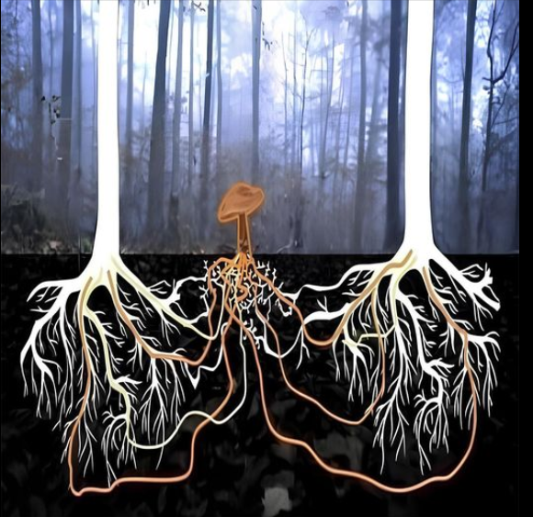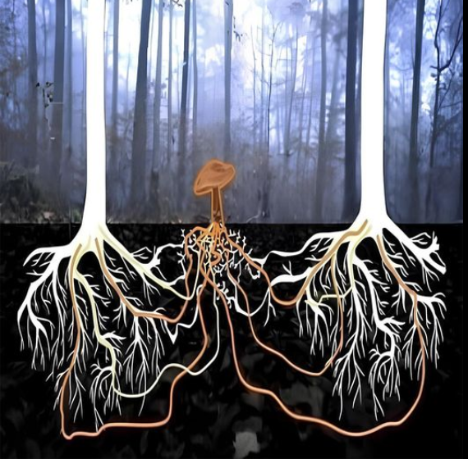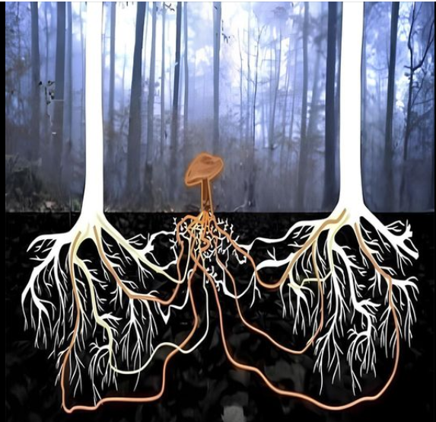Top of Form

Bottom of Form

Top of Form

Bottom of Form